Building Violations

<https://data.cityofchicago.org/Buildings/Building-Violations/22u3-xenr>

1. Real estate violation issue in the Chicago

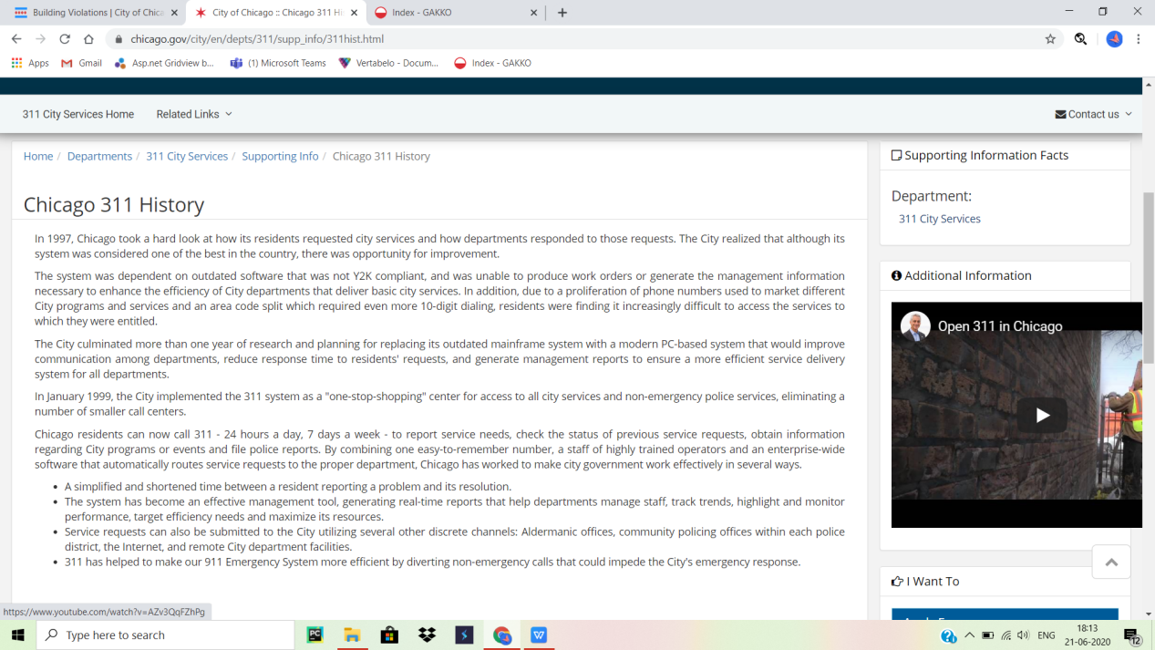

1. Inspection records of violation maintained by the city of Chicago department of building

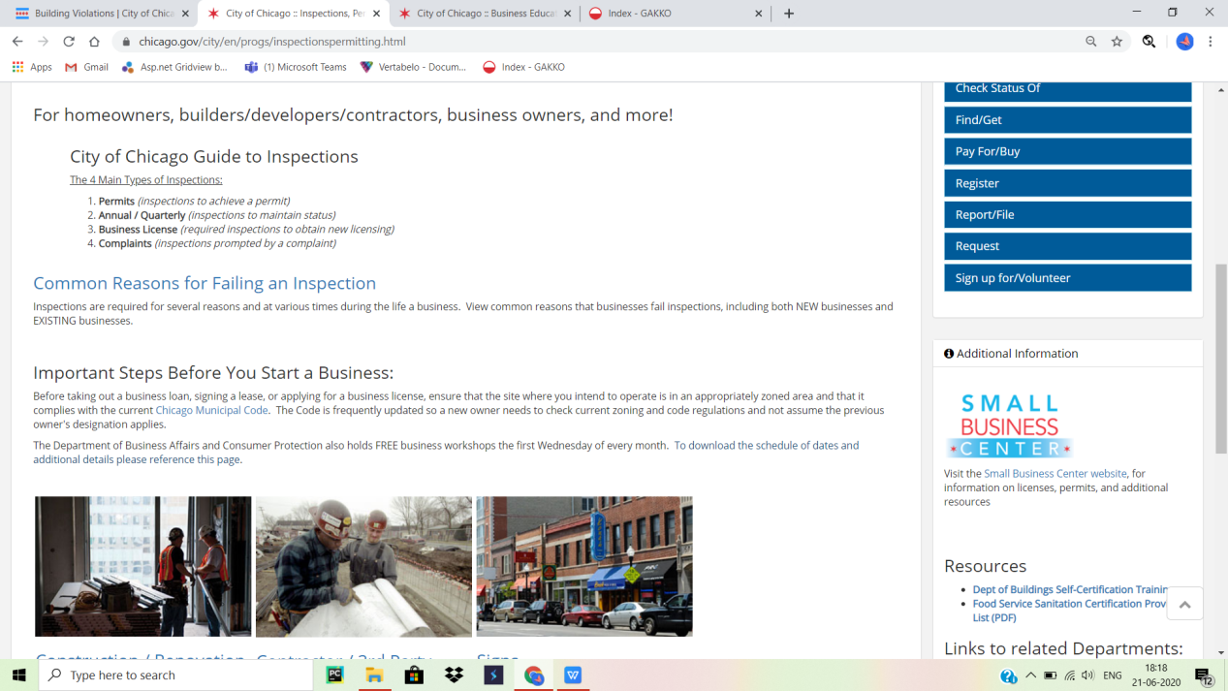

1. Easy permit excess by standard plan process

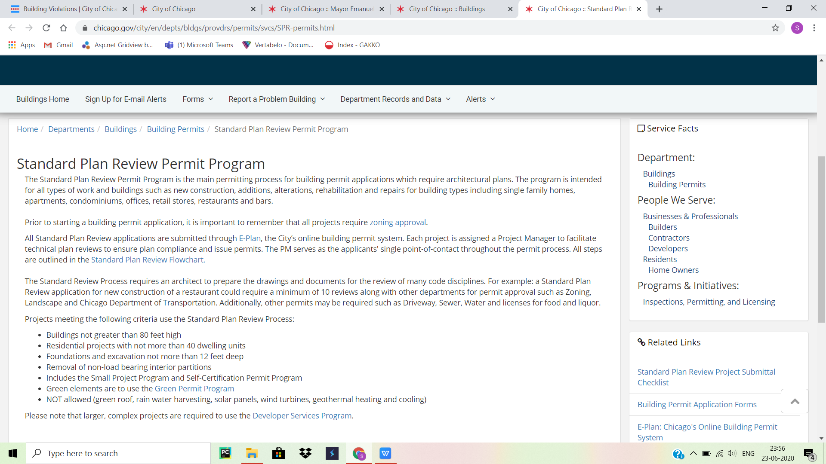

1. Last decades records of preBid/presubmittal conference attendees

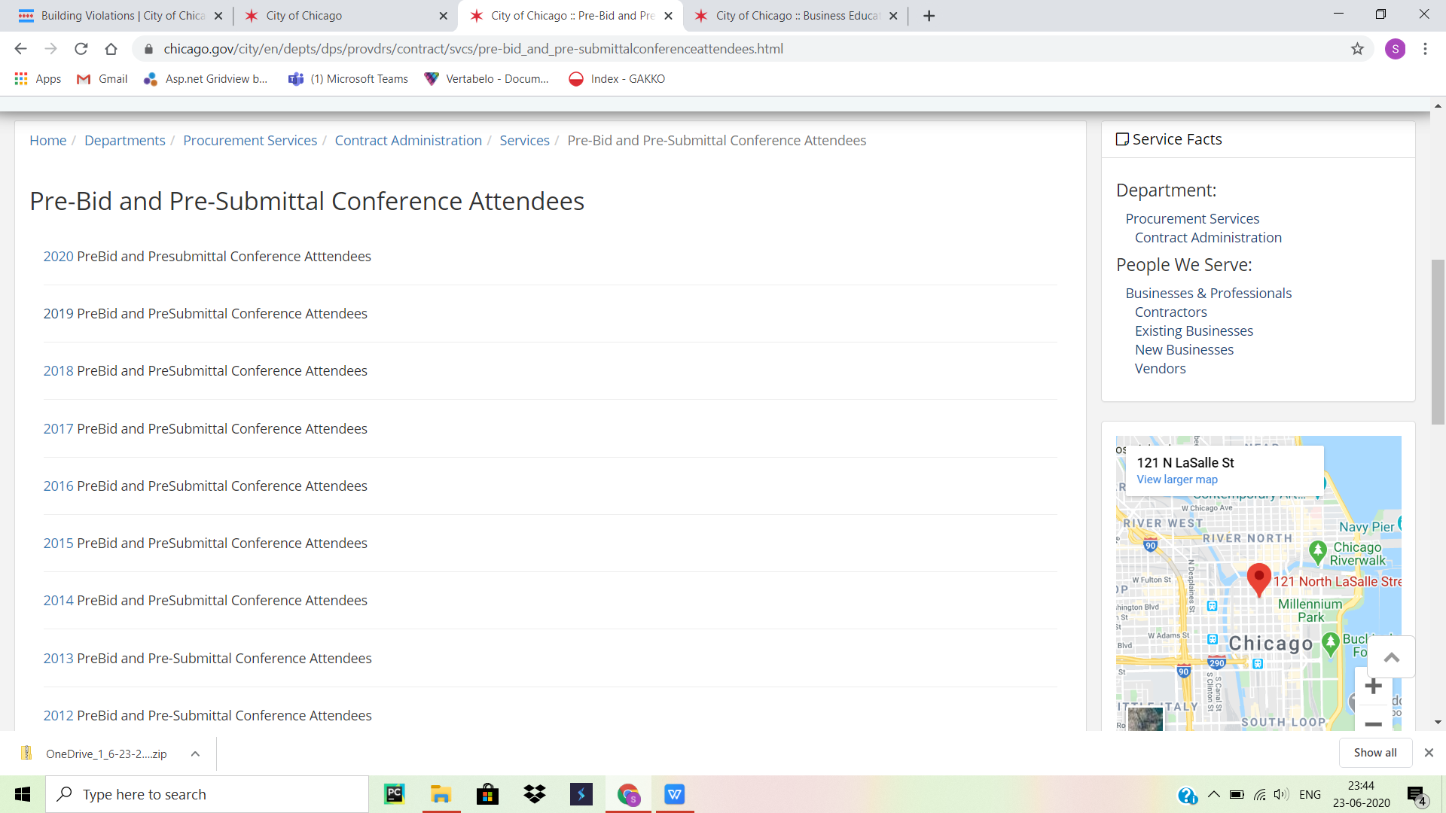

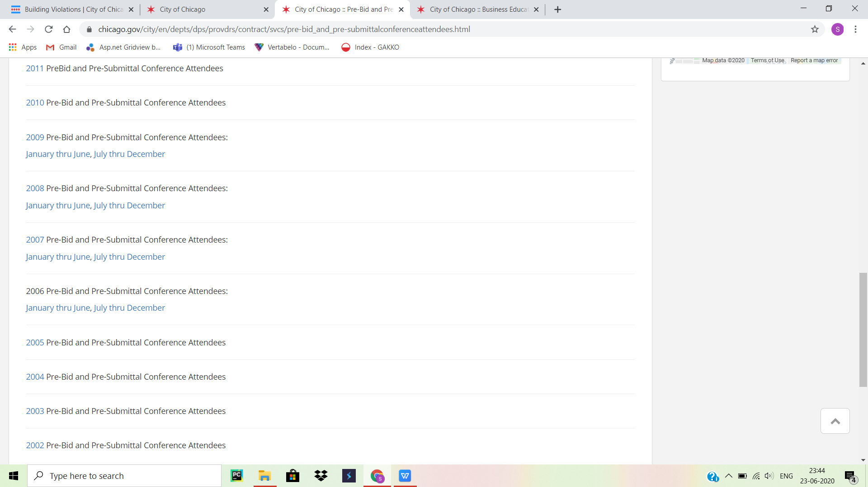

1. 2009 Chicago waste characterize study and waste diversion study results

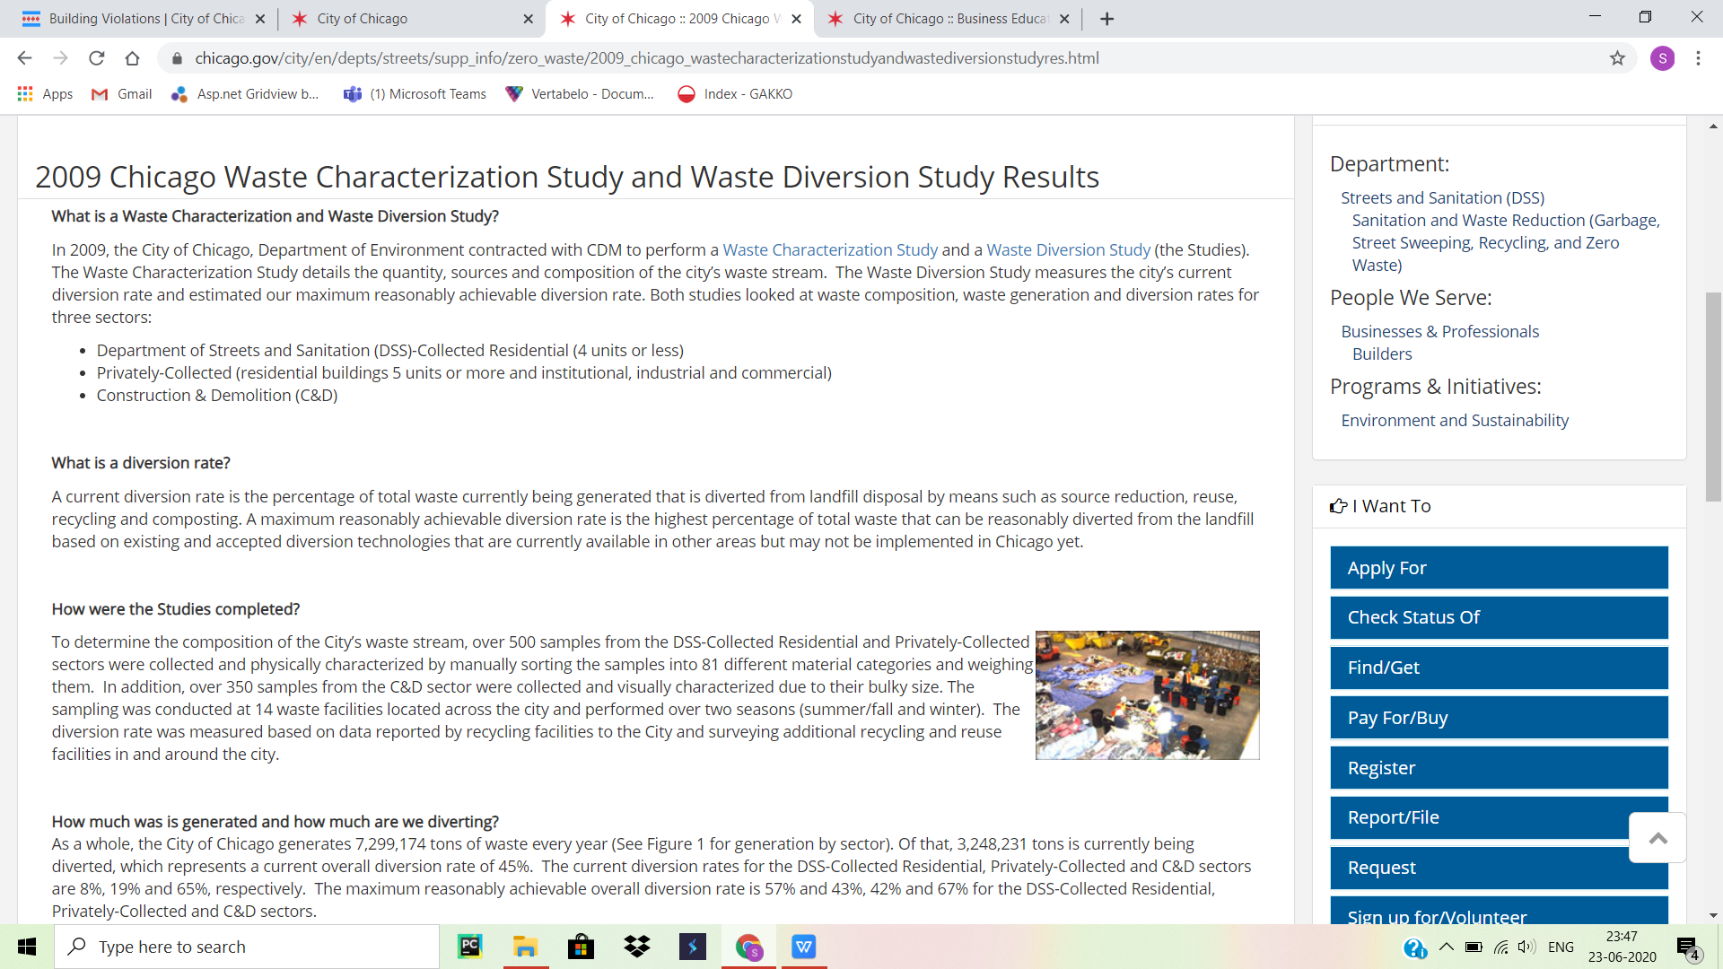

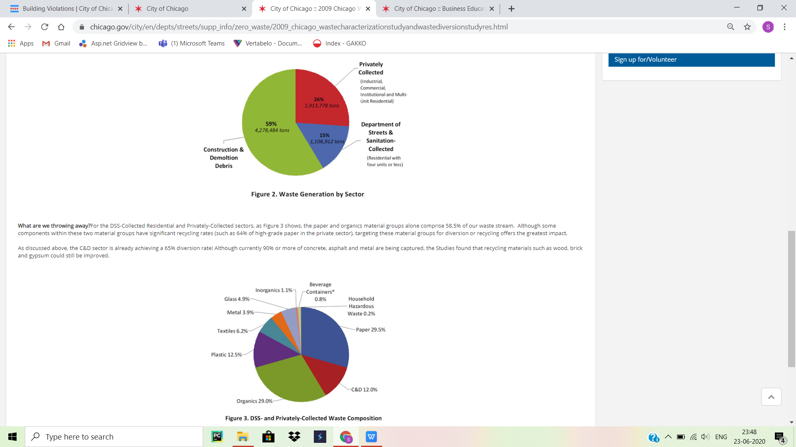

1. Large projects created by the private architecture and engineering
2. Developers news services and alerts related information

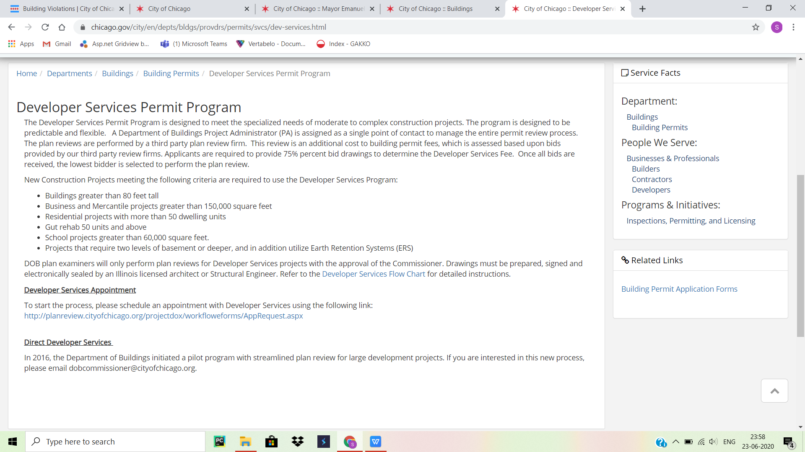

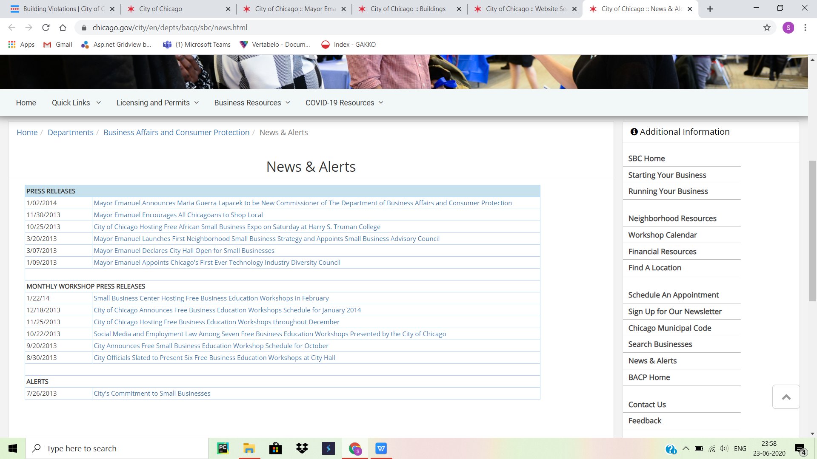

1. Residents like owners and renters supporting information
2. State government taken initiatives steps and programs
3. Four types of needed inspections and also common reasons for failing an inspection
4. Constructions/Renovation for making schools sidewalks and parks
5. Resources of building self-certification training and food services sanitation certification